**Nodejs setup**

**Prerequisites**:

1. git, for Centralized Version Control Systems and bower packages.
2. Node.js, used to run JavaScript tools from the command line.
3. npm, the node package manager, installed with Node.js and used to install Node.js packages.

**Steps:**

1. Check out the project from Git

Git clone <https://github.com/handaanmol/inventory-service>

1. Go to the VM created. Create a directory and copy the code into the directory.
2. Install globally express and pm2 using the following commands
3. Pm2 -PM2 is a process manager for Node.js applications with a built-in load balancer. It allows you to keep applications alive forever, to reload them without downtime and to facilitate common system admin tasks.

“npm install pm2 –g”

1. Express - Express is a minimal and flexible Node.js web application framework that provides a robust set of features to develop web and mobile applications.

“npm install express –g”

1. Cd into the services and run “npm install” command. The node modules required to run the services will be downloaded.
2. Start the service as a background process using pm2. Use the following command to run the services

“pm2 start --name="inventory-services" index.js –i 1”

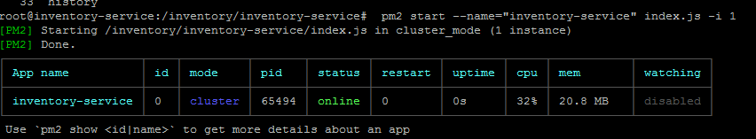

1. To check the pm2 process running use the command “pm2 list”

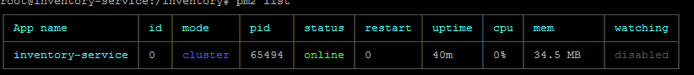

1. You can access the swagger

http://<YOUR_IP>:9001/inventory-service/apis/docs/

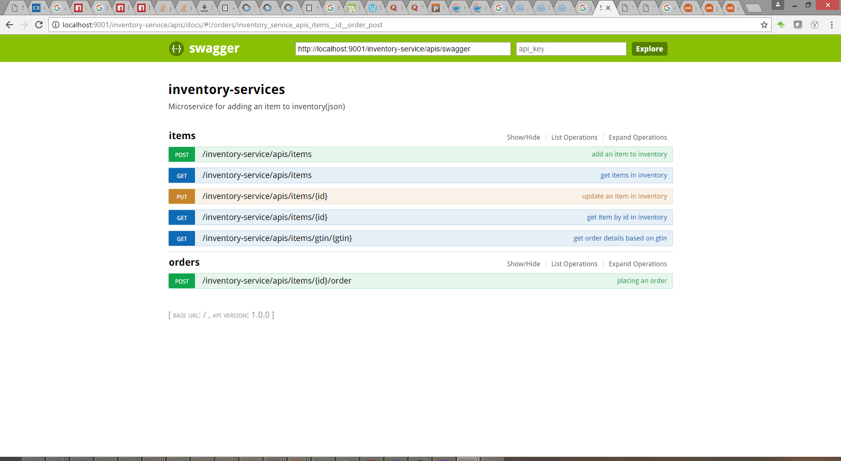

1. You can access the swagger at URL :

<http://52.191.162.82:9001/inventory-service/apis/docs/>